**Experiment No. – 2.1**

**Student Name: Milan Sharma UID: 23MAI10003**

**Branch: ME – CSE - AIML Section/Group: 23MAI – 1 (A)**

**Semester: 2nd Date of Performance: 21Feb2024**

**Subject Name: Machine Learning Lab Subject Code: 23 CSH 651**

Aim of the Experiment:

Implementing K-Means Algorithm using Python.

Theory:

**K-Means Clustering** is an Unsupervised Machine Learning algorithm, which groups the unlabeled dataset into different clusters. The goal of clustering is to divide the population or set of data points into a number of groups so that the data points within each group are more comparable to one another and different from the data points within the other groups.

K-Means Clustering works well with numerical data, where the concept of distance between data points is meaningful. It’s commonly applied to continuous variables. It does not predict labels for new data; it assigns them to existing clusters based on similarity. It is a centroid based algorithm, where each cluster is associated with a centroid.

Here K defines the number of pre-defined clusters that need to be created in the process, as if K=2, there will be two clusters, and for K=3, there will be three clusters, and so on.

**Steps for K-Means Clustering Algorithm:**

1. Select the number K to decide the number of clusters.
2. Select k random points from the data as centroids.
3. Calculate the distance of all observations to each of the k centroids.
4. Assign the observations to the closest centroid.
5. Find the new location of the centroid by taking the mean of all the observations in each cluster.
6. Repeat Steps 3-5 until the centroids do not change position..

**Example:**

Customer segmentation in marketing: K-means groups customers based on purchasing behavior, allowing businesses to tailor marketing strategies for different segments.

**Code:**

# Importing libraries

import pandas as pd

import numpy as np

import matplotlib.pyplot as plt

# Load the dataset

data = pd.read_csv('C:/Users/milan/OneDrive/Desktop/Clustering.csv')

data.head()

# Read the features

X = data[["LoanAmount","ApplicantIncome"]]

# Visualise data points

plt.scatter(X["ApplicantIncome"],X["LoanAmount"],c='black')

plt.xlabel('Annual Income')

plt.ylabel('Loan Amount (In Thousands)')

plt.title('Original Dataset')

plt.show()

# Step1 - Choose the Number of Clusters (K)

K=3

# Step2 - Select Random Centroid for each Cluster

Centroids = (X.sample(n=K))

# Plot the Centroids

plt.scatter(X["ApplicantIncome"],X["LoanAmount"],c='black')

plt.scatter(Centroids["ApplicantIncome"],Centroids["LoanAmount"],c='red')

plt.xlabel('Annual Income')

plt.ylabel('Loan Amount (In Thousands)')

plt.title('Dataset with Initial Centroids')

plt.show()

print('Initial Centroids: \n',Centroids)

# Step3 - Assign all the points to the closest cluster centroid

# Step4 - Recompute centroids of newly formed clusters

# Step5 - Repeat step 3 and 4

diff = 1

j=0

p=1

print("\nDifference between Previous and Current Centroids:")

while(diff != 0):

# XD will contain distance of each point from each cluster

XD=X.copy()

i=1

for index1,row_c in Centroids.iterrows():

ED=[]

for index2,row_d in X.iterrows():

# Calculate distance of each point to centroid

d1=(row_c["ApplicantIncome"]-row_d["ApplicantIncome"])**2

d2=(row_c["LoanAmount"]-row_d["LoanAmount"])**2

d=np.sqrt(d1+d2)

ED.append(d)

XD[i]=ED

i=i+1

# Store the Cluster number for each point

C=[]

for index,row in XD.iterrows():

min_dist=row[1]

pos=1

for i in range(K):

if row[i+1] < min_dist:

min_dist = row[i+1]

pos=i+1

C.append(pos)

XD["Cluster"]=C

Centroids_new = XD.groupby(["Cluster"]).mean()[["LoanAmount","ApplicantIncome"]]

if j == 0:

diff=1

j=j+1

else:

diff = (Centroids_new['LoanAmount'] - Centroids['LoanAmount']).sum() + (Centroids_new['ApplicantIncome'] - Centroids['ApplicantIncome']).sum()

print("Round",p,": ",diff.sum())

p=p+1

Centroids = XD.groupby(["Cluster"]).mean()[["LoanAmount","ApplicantIncome"]]

# Plot Clusters with differnt colors

color=['blue','green','cyan']

for k in range(K):

data=XD[XD["Cluster"]==k+1]

plt.scatter(data["ApplicantIncome"],data["LoanAmount"],c=color[k])

plt.scatter(Centroids["ApplicantIncome"],Centroids["LoanAmount"],c='red')

plt.xlabel('Income')

plt.ylabel('Loan Amount (In Thousands)')

plt.title('Different Clusters with Centroids')

plt.show()

Output:

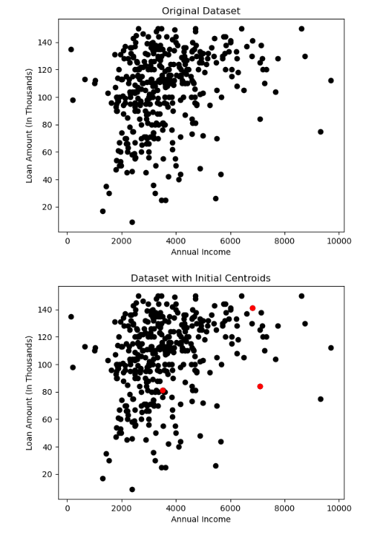

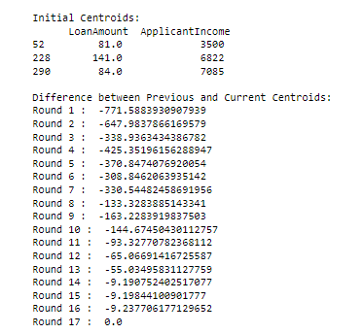

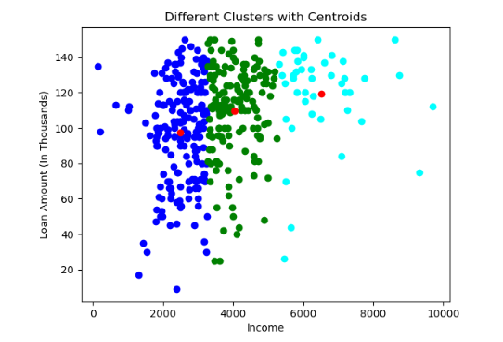

**Learning Outcomes:**

1. **I learnt about various python libraries like pandas, matplotlib and numpy.**
2. **I learnt about the concept of K-Means Clustering Algorithm.**
3. **I learnt about how to select the value of K to determine clusters.**
4. **I learnt about how to assign data points to different clusters.**
5. **I learnt about how to calculate the Euclidean Distance.**